SECTION ONE – MULTIPLE CHOICE (10 marks)
This section has 10 questions. Answer all questions on the separate multiple-choice answer sheet provided.

1. Force is measured in
a. kilograms
b. litres
c. tonnes
d. newton

2. Which of the following is a contact force?
a. electrostatic
b. magnetism
c. friction
d. gravity

3. Which of the following is ONLY a pulling force?
a. electrostatic
b. magnetism
c. friction
d. gravity

4. All cars, bicycles and automobiles have brakes to make them stop. Brakes work by increasing the
a. gravity
b. friction
c. mass
d. weight

5. A block suddenly moves across the table. The reason why it moves is:
a. there is very little gravity
b. there is a force applied to the block
c. magic
d. friction

6. A force is described as
a. A push only
b. A pull only
c. A push or pull
d. None of the above

7. When you slide a box across the floor what force must your push be stronger than?
a. Support Force
b. Friction force
c. Gravity
d. Air Resistance

8. Which force always pulls downwards on objects?
a. Friction
b. Magnetic
c. Gravity
d. Electrostatic

9. A paper is sitting at rest on your desk. Which of the following statements best describes this situation?
a. There are NO forces acting on your paper
b. Your paper pushes on the desk only
c. The desk pushes up on the paper only
d. The forces acting on the paper are balanced.

10. What can a force NOT do to an object?
a. increase the mass
b. Accelerate or decelerate
c. change direction
d. change shape or size

11. Touching a Van Der Graaf Machine made the teacher’s hair stand on its ends. What is the force that did this?
a. Friction
b. Magnetic
c. Gravity
d. Electrostatic

12. What is the Law of Magnetism?
a. Like poles attract and unlike poles repel
b. Like pole repel and unlike poles attract
c. What goes up must come down
d. To obtain, something of equal value must be sacrificed.

13. What is one reason why you would want to reduce friction?
a. climbing a wall
b. ice skating
c. breaking
d. opening a parachute

14. A change to an object’s motion is caused by….
a. Balanced Forces
b. Unbalanced Forces
c. Acceleration
d. Velocity

15. What is the actual magnetic pole where the geographic North Pole is
a. North
b. East
c. South
d. West



ANSWER BOOKLET

NAME:

FORM: DATE:

Multiple Choice Short Answer Total

/15
/20

/35

/20
/25

SECTION ONE: Multiple choice answers
Cross (X) through the correct answer.
1 | a | b | c | d
2 | a | b | c | d
3 | a | b | c | d
4 | a | b | c | d
5 | a | b | c | d
6 | a | b | c | d
7 | a | b | c | d
8 | a | b | c | d
9 | a | b | c | d
10 | a | b | c | d
11 | a | b | c | d
12 | a | b | c | d
13 | a | b | c | d
14 | a | b | c | d
15 | a | b | c | d

SECTION TWO: Short Answer (20 marks)
1.
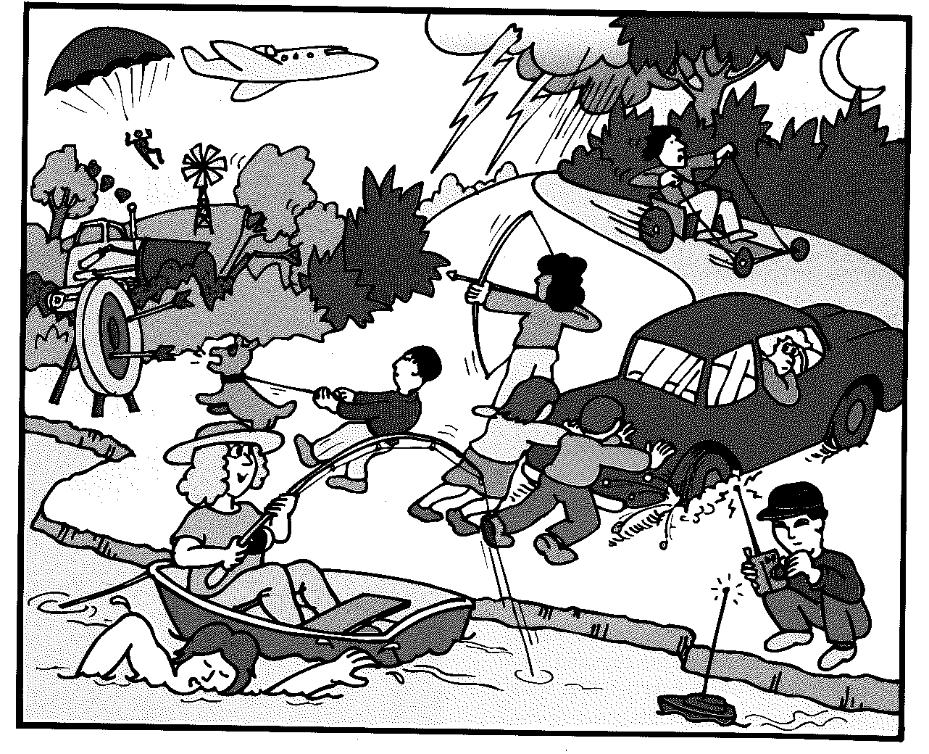
- Draw a circle in the picture of an example of a push force (1 mark)
- Draw two crosses in the picture where there are 2 examples of a pulling force (2 marks)
2. Match the definition of terms to the words (i to iii).
(3 marks)
a) friction | i) a force that opposes the motion of an object
b) mass | ii) a force that pulls or pushes on other materials such as iron and other metals
c) magnetic | iii) is the amount of matter in an object

3. Johnny put 2 magnets close to each other. Describe what would happen if
a) Two North Poles were facing each other (1 mark)
________________________________________________________________________
b) A North and a South Pole were facing each other (1 mark)
________________________________________________________________________
c) Two South Poles were facing each other (1 mark)
________________________________________________________________________
4. a) List 2 ways that you can reduce friction (2 marks)
________________________________________________________________________
________________________________________________________________________
b) Name one reason why you would want more friction (1 mark)
________________________________________________________________________
________________________________________________________________________
5. True or False (4 marks)
a) If the forces acting on an object are balanced then it is not moving. ______
b) Gravity is a contact force _________
c) An object moving at constant speed has an unbalanced force _______
d) Magnets only have a repelling force _______
6. Determine whether the object forces are balanced or unbalanced by circling one. (4 marks)
a) Balanced / Unbalanced
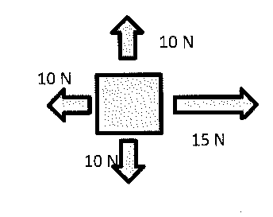
b) Balanced / Unbalanced
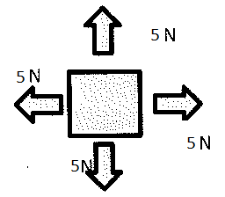
c) Balanced / Unbalanced
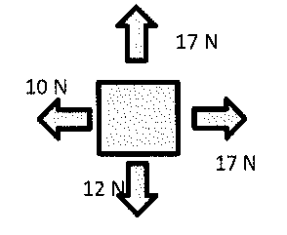
d) Balanced / Unbalanced
